1. Find a topological order for the graph in the following figure   
   **S-->G-->D-->A-->B-->H-->E-->I-->F-->C-->t**  
   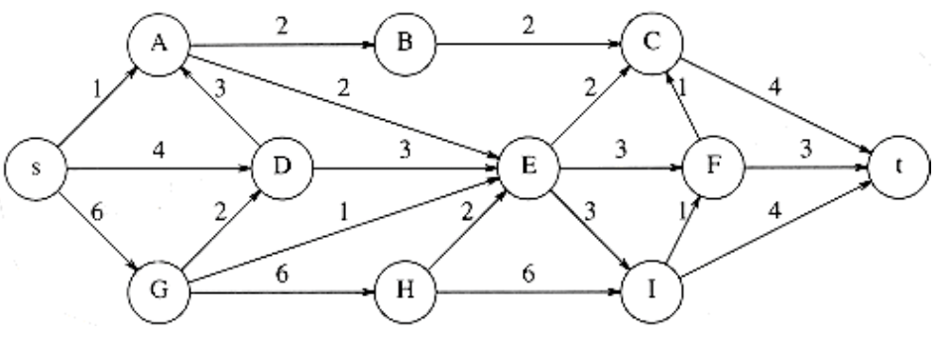

The topological order is as such because **S** has no receiving inputs, therefore we can remove it. The next node we can remove is **G** as **S** is the only connector. Once **S and G**  are removed as projecting nodes, **D** no longer has any inputs, therefore we can remove it. Afterwards, **A** will have no inputs because **S & D** are removed, therefore we can remove it (by this point we are at **S-->G-->D-->A**). Continuing with **A** and its removal, we can remove **B** because we have no incoming connectors (**S-->G-->D-->A-->B**). Now we have to turn our attention to the next node without incoming receptors, **H,** and we can remove it ((**S-->G-->D-->A-->B**→**H**), and now we can remove **E,** as all of its connectors are removed. Now that **E & H** are no longer projecting onto **I**, we can remove it as well (**S-->G-->D-->A-->B-->H-->E-->I→).** With **I & E** eliminated, we can remove **F (**(**S-->G-->D-->A-->B-->H-->E-->I→F)**. And, now that **B & F** are removed and no longer connecting onto **C**, we can remove it, and this will allow us to complete the topological order, with **t** being the last node without any connectors, and resulting in this topological order: **S-->G-->D-->A-->B-->H-->E-->I-->F-->C-->t**

1. Find all pairs of shortest distances for the following graph

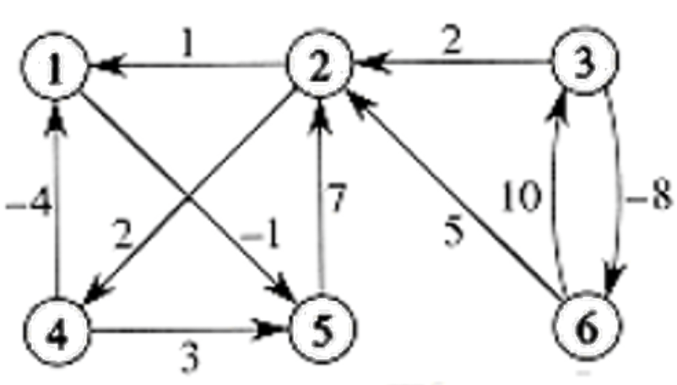

**D0 (Initial pairs) D6 (FINAL STATE/PAIRS)**

0 ∞ ∞ ∞ -1 ∞ 0 6 ∞ 8 -1 ∞

1 0 ∞ 2 ∞ ∞ -2 0 ∞ 2 -3 ∞

∞ 2 0 ∞ ∞ -8 5 -3 0 -1 -6 -8

-4 ∞ ∞ 0 3 ∞ -4 2 ∞ 0 -5 ∞

∞ 7 ∞ ∞ 0 ∞ 5 7 ∞ 9 0 ∞

∞ 5 10 ∞ ∞ 0 3 5 10 7 2 0

// BEGIN Floyd-Warshall algorithm for finding shortest paths

// Initialize the distance matrix with size n and set all distances to infinity

n = 6 // Number of vertices in the graph

initialize d[n][n]

FOR i from 1 to n

FOR j from 1 to n

d[i][j] ← ∞

END FOR

END FOR

// Set the distance from each node to itself to 0

FOR v from 1 to n

d[v][v] ← 0

END FOR

// Step 3: Set initial distances based on direct edges (where 'u' is the starting node, 'v' is the ending node, and 'w' is the weight of the edge)

FOR ALL edges (u, v) with weight w in the graph

d[u][v] ← w

END FOR

// Step 4: Update the matrix for all pairs of nodes

FOR k from 1 to n

FOR i from 1 to n

FOR j from 1 to n

// If a shorter path is found via node k, update the distance

IF d[i][j] > d[i][k] + d[k][j]

d[i][j] ← d[i][k] + d[k][j]

END IF

END FOR

END FOR

END FOR

// END of algorithm, d6 contains the shortest paths between all pairs

// Note on reading the final matrix:

// To find the shortest path from node 'n' to node 'm', refer to d[n][m].

// Note that the indexing starts from 1, so d[1][1] corresponds to the path from node 1 to itself.

// If d[n][m] contains infinity (∞), it means there is no path from node 'n' to node 'm'.

// Example run for updating matrix D1 using node 1 as an intermediate node

// Example run for updating matrix D1 using node 1 as an intermediate node

// This process is repeated for each node (from 1 to n) to obtain the final matrix D6

FOR i from 1 to 6

FOR j from 1 to 6

// Update d[i][j] if a shorter path through node 1 is found

d[i][j] = min(d[i][j], d[i][1] + d[1][j])

// The resulting D1 matrix after considering paths through node 1:

0 ∞ ∞ ∞ -1 ∞

1 0 ∞ 2 0 ∞

∞ 2 0 ∞ ∞ -8

-4 ∞ ∞ 0 -5 ∞

∞ 7 ∞ ∞ 0 ∞

∞ 5 10 ∞ ∞ 0

// to be ran from D1 🡪 D6, with D6 being the final output